**UML DIAGRAMES**

Class Diagram - https://drive.google.com/file/d/1c_hVMtvQX1TDZzzp2Fp5TbqT0fJR8abk/view?usp=sharing

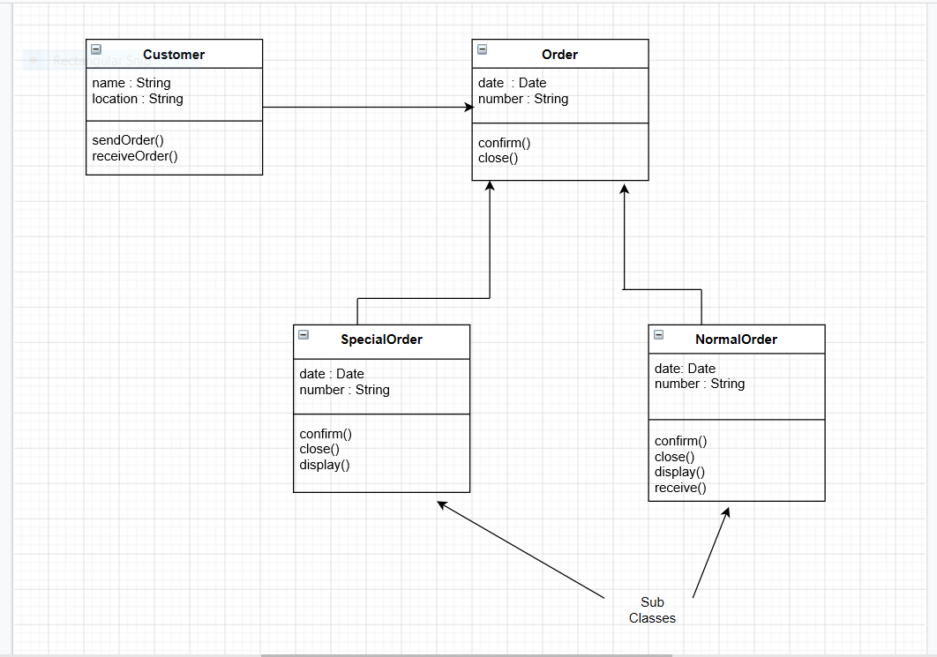

Use Case Diagram - <https://drive.google.com/file/d/1xeTJ2y93a7SNTnqV37dGrWt_HWPPK2uL/view?usp=sharing>

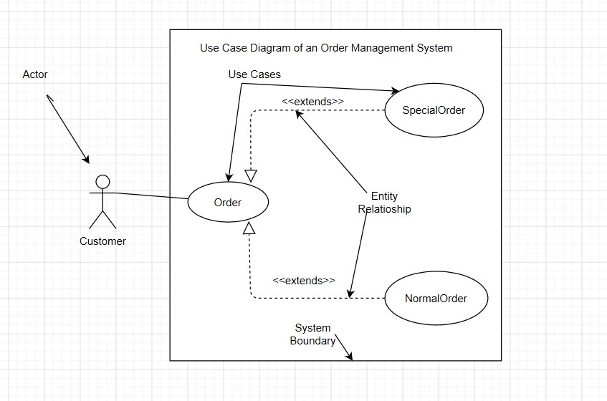

Sequence Diagram - <https://drive.google.com/file/d/1xC57qzLaA502UEOmov_y9FAaf22f5v3I/view?usp=sharing>

